**Lab 1**

Start PICSimLab. Select PIC16F877A as microcontroller using the microcontroller tab. Select McLab2. Select 4 Mhz clock. Configure the microcontroller through your code as follows:

__CONFIG _FOSC_XT & _WDTE_OFF & _PWRTE_OFF & _MCLRE_OFF & _BOREN_OFF & _LVP_OFF & _CPD_OFF & _CP_OFF

Program the microcontroller so that

1. when S1 is pressed, LED L2 is turned on,
2. when S3 is pressed LED L4 is tuned on.

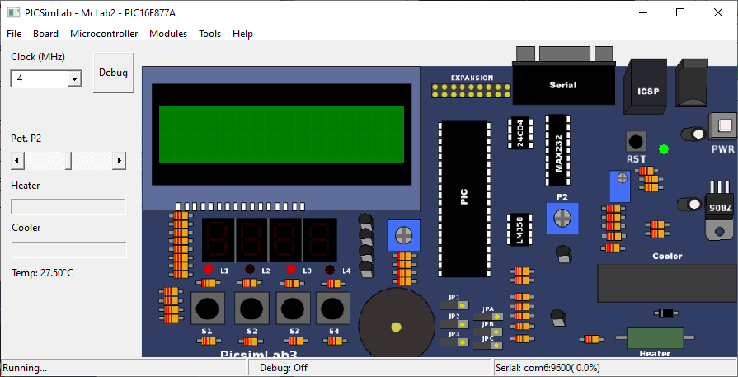

Create a video which displays:

1. the code you prepared on MPLAB,
2. the code is successfully built (compiled),
3. the HEX output is loaded onto PICSimLab,
4. the board works as described in this manual.

The video should include your video in the upright position while you are performing the above actions.

The video filename should be named as follows:

Microprocessors_Lab_1_StudentNumber_Name_Surname.mp4

*Example:*

*Microprocessors_Lab_1_69284571_Mehmet_Kocaturk.mp4*

Please only upload this video file into Microsoft Teams assignment.